EXPERIMENT 11
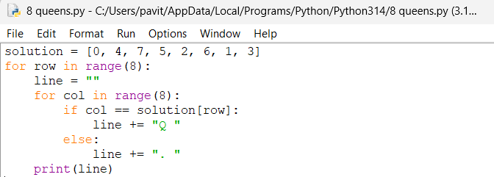

OUTPUT
